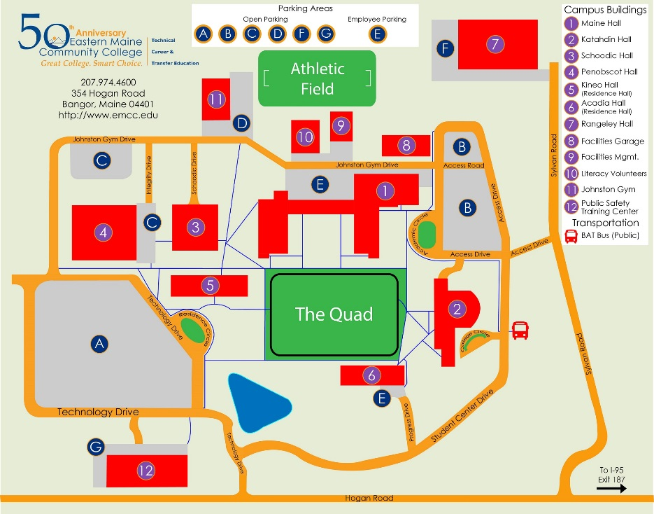
Directions to EMCC Campus:
From I-95 northbound, take exit 187 to Hogan Road. Turn right onto Hogan Road and at the first set of lights, turn right onto Sylvan Road. Turn left immediately following “Great Skates” roller skating rink.
From I-95 southbound, take exit 187 to Hogan Road. At the street light, turn left onto Hogan Road. Proceed through one set of lights just after the interstate overpass. At the next set of lights, turn right onto the Sylvan Road. Turn left immediately following “Great Skates” roller skating rink.

REVIEW COURSE WILL BE IN: MAINE HALL ROOM 117

